|  |  |
| --- | --- |
| Image result for erp  Enterprise Resource Planning  19/5/2024 | Abstract  I work as a software engineer at “ERP Solution Experts” which is an IT company specializing in training and implementing ERP software.  Hasan Alhwietat |

Contents

Define the term ERP and why it is different from conventional software packages and programs. 1

Explain the factors/software that contributed to the evolution of ERP systems that we have currently in the market. 3

Evaluate the benefits and drawbacks of using ERP solutions for businesses. 5

Compare three types of ERPs available in the market and justify, with specific examples, the key features of each ERP solution 6

Discuss in general the process of implementing ERP solutions. 9

Provide information about the lifecycle of module implementation. 10

Explain how the proven path can help implement ERPs successfully. 11

Evaluate the impact of ERP solutions on the economy 14

Odoo Final: - 16

Create transactions across multiple modules of your Odoo ERP system. 16

Adjust privileges for each employee according to their responsibilities taking into consideration corresponding Access Rights. 19

Sample reports from previously created transactions: 20

Resources: - 22

# Define the term ERP and why it is different from conventional software packages and programs.

ERP (Enterprise Resource Planning): It is a specific type of enterprise system that integrates data through which it supports most of the main functions of companies. It is a comprehensive software platform used by institutions and companies to manage business processes across various departments to simplify functions and workflow through automation and integration, including human resources, supply, procurement, finance, information technology, and others. It aims to facilitate processes between employees within the organization or company and communicate with external stakeholders, allowing real-time data flow between functional applications. It is a web-enabled system that operates using customers, employees, vendors, etc.

Difference from Conventional Software packages and programs:

|  |  |  |
| --- | --- | --- |
| Compare | Conventional Software packages | Erp Software |
| Integration | It deals with a single function or process, such as accounting programs or a specific system, and the data is limited to one section, which makes integration limited with other programs. | This system deals with more than one process or function so that it integrates all these processes into one system for smooth communication and data transfer across various departments due to the possibility of integration. |
| Database | A limited database allocated to one department is used and is not shared with other departments, which leads to data duplication and lack of consistency. | This system deals with more than one process or function so that it integrates all these processes into one system for smooth communication and data transfer across various departments due to the possibility of integration. |
| Real-Time Data | It requires manual intervention to transfer modern information through the systems, and this causes problems in responding quickly to instantaneous changes, which causes financial problems for the company. | High speed in responding to changes due to sharing data between departments that occur in the markets thanks to the possibility of processing data in real time, which enhances the ability of companies to respond quickly to changes. |
| Process Standardization | You need to perform many operations to unify the data. It is complex and difficult to integrate many operations because they are considered isolated from the system and do not integrate smoothly. | It standardizes operations to make it easier for stakeholders to know details such as imports, exports, stored quantities, sales, and profits. This standardization leads to increased efficiency and ease of procedures. |
| User Experience | It is an interface dedicated to one system or function so that it is not interconnected with other systems and requires training for each package, which leads to complexity. | The interface is consistent and easy to use so that it meets the needs of the users and requires comprehensive training to make the user take great advantage of the features and characteristics. |

# Explain the factors/software that contributed to the evolution of ERP systems that we have currently in the market.

ERP Evolution from book ESFM:

Inventory Management & Control (1960s) Most organizations built and designed silo systems for their departments, and with more complex management to automate inventory and production schedules, most systems were designed on mainframe computers using languages such as COBOL and ALGOL. The systems saw efficiency in assisting factory managers by knowing sales, inventory, and productivity. The mid-seventies were the birth of Materials Requirements Planning (MRP), which included planning product requirements according to the main production schedule, and then in the eighties it was developed into (MRP-II). The focus was on improving manufacturing processes and synchronizing it with production requirements, and included areas such as store management, projects, and finance. And engineering, etc., which witnessed the emergence of the ERP system for the first time in the nineties, which showed an integrated solution to the increasing complexity of the systems, as it integrated the various processes into one system, making their consistency and flexibility across all functions using database programs, programs, and packages. Then ERP - II expanded in the 2000s to include the integration of common systems. And data exchange, so the development process took place from the old central applications to the client-server architecture, so that flexibility became more efficient and productive in business using applications such as SCM, CRM, and SFA.  
  
ERP Evolution from book Wiley:

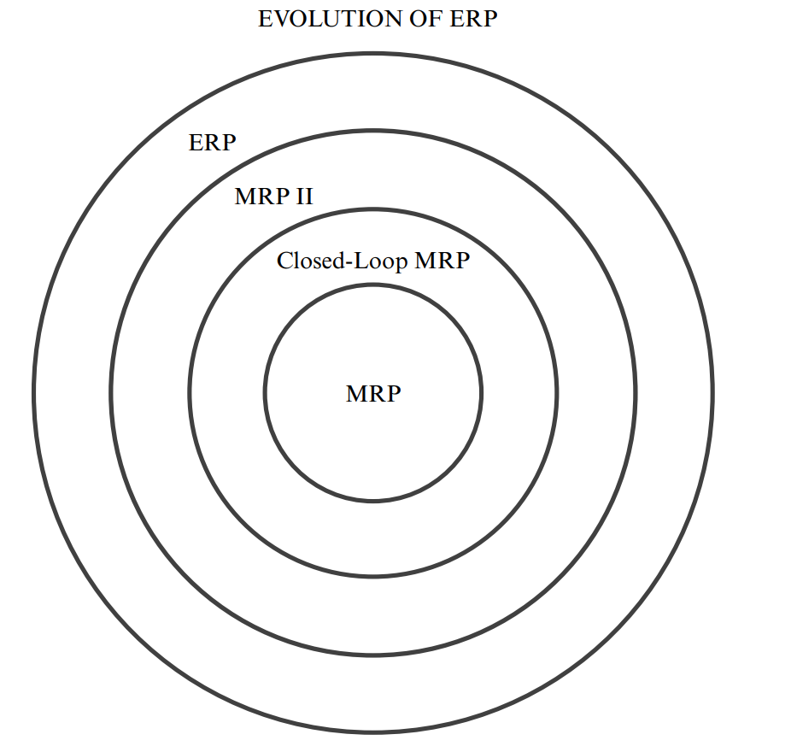

1. Step One—Material Requirements Planning (MRP): ERP began in the sixties of the twentieth century as MRP. Its inventors were looking for a way to improve the process of ordering materials and components. Through research and experiments, they found this technology to be the best in achieving requirements and uses the main schedule (What will we make?), the bill of materials (what does it take to make?), and in inventory records (what do we have?) to determine future requirements (what do we have to arrive at?). To get a visual representation of the products you want to store, this method helps companies manage inventory.
2. Step Two—Closed-Loop MRP: MRP developed rapidly by discovering a better way to order and users discovered greater features such as order due dates after issuing orders, which caused a boom in the field of manufacturing so that there was a formal mechanism for maintaining priorities in a constantly changing environment. Because change does not occur due to one or two possibilities, but rather based on certainty, which led to the name priority planning. Techniques to assist in planning capacity requirements were also linked to material requirements planning, which led to a development in tools such as forecasting, sales planning, and data analysis until it reached the closed-loop MRP that is distinguished. With important features, including tools to address priorities and capabilities and support planning and implementation, ensuring feedback loops that help maintain priorities despite changing circumstances.
3. Step Three—Manufacturing Resource Planning (MRP II): There has been direct and significant growth over closed-loop MRP through three additional elements: First, sales and operations planning, through which you can achieve a balance between supply and demand and thus provide management with information that is beneficial to the business. Second, the financial interface, so that Converting all unit operating plans into financial terms. Third, simulation so that questions are asked and answered so that these answers are made executable. However, current advanced planning systems (APS) allow effective simulation at very detailed levels. MRP is a method for effectively planning all a manufacturer's resources. It addresses operational and financial planning and the ability to simulate to answer questions related to many functions such as business planning, sales, operations, production, material requirements, etc. In order to improve the decision-making process.
4. Step Four—Enterprise Resource Planning (ERP): The basics in ERP are the same as in MRP II, but thanks to enterprise programs, business processes have been made broader and more effective in dealing with multiple business units. In fact, financial integration has become stronger with the possibility of a graphical display of resource planning. ERP balances It predicts demand and supply at the enterprise level by linking customers and suppliers in a complete supply chain and coordinating between sales, finance, purchasing and human resources. It provides real-time integration of sales and operational data, and its primary purpose is business management in a rapidly changing environment with competitiveness between institutions.

# Evaluate the benefits and drawbacks of using ERP solutions for businesses.

Benefits:

1. An increase in the productivity and sale of books through information integration and data merging so that data is entered once.
2. Easier management through standardization of operations and coordination between departments to know the quantities of books stored in warehouses, monthly sales, profits, etc. to improve efficiency and reduce errors.
3. Lower costs and higher profits and return on investment as a result of integration between programs. Through features and services, you can reduce the number of employees in the book store. You can also add features at a lower cost than other systems.
4. Improving data, its security and reliability. When a consistent and linked system is built between departments, the data will be more accurate and easier for users and stakeholders.
5. It helps in decision-making and report preparation processes. For example, we can know the best-selling books, special needs in human resources and financial matters, and the possibility of changing decisions based on changes in the market and making the organization keep pace with developments.
6. Improving customer service by using the system. The user will find complete ease in moving between the specified sections that suit his needs without any complications in buying or selling operations or by reviewing the contents of books and placing user information in one place.
7. The possibility of development and expansion to suit the needs of users by adding a new section or feature to the system

Drawbacks:

1. The most negative thing is the costs of preparing a system for large institutions, as they require a high budget of allocation, licenses, and other things to create a system specific to the company.
2. Creating a custom system takes a lot of time for production, which disrupts the company’s business process and leads to more complications in operations, which leads to weak financial returns and a longer implementation period.
3. The risk of indirect data loss, which leads to the cessation of business and financial problems for the company
4. The lack of many features of financial reports and predictive planning that institutions need to know their future needs
5. Converting data from the old system to the new can lead to a very complex process for creating processes

# Compare three types of ERPs available in the market and justify, with specific examples, the key features of each ERP solution

(Hernandez, 1/12/2023)

|  |  |  |  |
| --- | --- | --- | --- |
| Compare | On-premise ERP | Cloud-based ERP | Hybrid ERP |
| Define | It is a local, on-site program that is within the organization and is hosted on the organization’s devices and servers. It is fully controlled with the possibility of wide customization as needed. It is maintained by the organization’s IT staff. | It is a web service that provides a SAAS service, where each organization accesses its stored data. All of these services are received in exchange for a subscription to the service, and include support, updates, training, and customizations. They are accessed through the browser. | It is a joint application of cloud-based and on-premise ERP system solutions. The two types are mixed so that some resources are on local servers and others are on the cloud. |
| Features | 1- Provides the highest levels of data and program control and customization on a large scale to suit the needs of users  2- It provides security so that data is stored locally and is useful for large companies that are subject to compliance laws  3- It provides high performance because it does not depend on a direct Internet connection | 1- The construction costs in the beginning are small and do not require large-scale equipment due to the presence of suitable subscriptions for all groups, large and small.  2- Access to it via the Internet from anywhere, allowing for remote work and access to data in real time  3- It reduces the burden of information technology because maintenance and updates are carried out by the company providing the service  4- It is easy to add or remove a feature or service as needed in order to expand | 1- It combines cloud-based and on-premise systems so that important data is stored on site while other functions are on the cloud.  2- The possibility of gradually building a hybrid system from local or cloud components  3- It allows the possibility of data recovery due to the use of the cloud system in business  4- Integration with the best business cloud services and three-party applications |
| Drawbacks | 1- Construction costs are high due to the purchase of licenses, devices, servers, and the development process  2- Continuous maintenance and development that requires a specialized team to develop it  3- Expansion can cause problems in the company’s infrastructure due to rebuilding a larger infrastructure, which means huge financial investment and new licenses. | 1- Most companies have concerns about storing their data off-site because they doubt the possibility of being attacked by hackers.  2- It relies heavily on the Internet in order to obtain services and optimal performance, which causes failure of the Internet connection to accessibility problems.  3- Companies have low control over the infrastructure and system | 1- It requires many additional resources for seamless integration between Cloud-based and On-premise, so the management is complex.  2- It requires large costs due to the need for infrastructure and cloud subscriptions  3- Customization is available, but due to the cloud component, it is limited |
| Example | SAP, Oracle E-Business | Odoo, Oracle NetSuite | Microsoft Dynamics 365, Infor Cloud Suite |
| Deployment | Local servers | Cloud servers | Combination of both |
| Control | Full control | Limited control | Partial control |
| Customization | High | Limited | Moderate |

|  |  |  |  |
| --- | --- | --- | --- |
| Compare | SAP | Odoo | Microsoft dynamics 365 |
| Define | It is a German company that provides an enterprise resource planning program to manage operations between customers and the organization. It helps companies manage their financial and commercial affairs, human resources, etc. This system integrates all data within one system. | It is a Belgian company that provides business management tools such as accounting, e-commerce, project management, inventory, and CRM. These services are provided in exchange for a subscription, hosted through the cloud, in addition to an open-source version to cover all companies’ needs. | It is a set of business applications provided by Microsoft that allows the integration of the work that is done in the company and the cloud, so that it allows organizations to improve efficiency, reduce the complexity of the business, and control the business and services provided by both parties, so that it connects the businesses so that it allows them to talk to each other. |
| Feature | 1- Greater customization specific to each company, which gives it complete control over the existing system and services and makes them unique.  2- Scalability so that it grows with the company’s needs and requirements by improving the infrastructure.  3- Provides higher security due to complete control of data and its transfer between departments.  4- Integration with other departments in one system for efficient business operations. | 1- It brings together various businesses in one platform.  2- It allows companies to choose the appropriate tools they need within the platform.  3- It has the ability to modify because it is open source.  4- Lower costs for companies because they do not need a large infrastructure in order to build a business management system.  5- The presence of a dynamic system that is adaptable to the business and helps with sleep.  6- It helps in increasing the efficiency of institutions through innovative strategies and provides solutions for various fields. | 1- Provides flexibility to combine local and cloud services.  2- It provides a comprehensive view of the business operations between the company and customers, through which business-related problems are identified and the possibility of reducing these. complications.  3- It works to improve customer needs and keep pace with the labor market by accelerating operations in order to meet market trends.  4- The possibility of expansion and accelerating innovation before other competing companies. |
| Justification | It provides flexibility to customize every aspect of the business to meet the needs and makes using this process customization specific to each company and makes each company have its own unique processes, which increases its sleep and scalability and provides high security due to complete control of the data and infrastructure and compliance with security laws and makes companies control the performance of the system. Its own because it is responsible for it and seeks to improve it and expand the scope. | Expandability with the growth of the company and the possibility of adding new features or functions with great ease without the need for the company’s infrastructure. This helps small companies improve the functions they provide and provide flexible and more effective solutions to customers at the lowest costs, so that these services are provided through subscriptions and through the cloud, the system is accessed. And easy to access from anywhere via the Internet. | It allows the integration of local and cloud services so that data and sensitive matters are kept within the company, while customer jobs and the convergence of services and other functions remain on the cloud. Services are usually chosen based on the company’s needs, and this makes the company able to recover from accidents and problems due to the presence of backup copies on the cloud. In order to preserve data and business progress, it also makes companies control the company’s financial matters by managing them through the budget. For example, instead of paying a lot on infrastructure for development, they can use the features on the cloud quickly in implementation and at the lowest costs. |

# Discuss in general the process of implementing ERP solutions.

1. Requirements Gathering and Definition: Through which the organization’s needs are understood and documented and the scope of the project is determined by holding meetings with stakeholders to collect requirements and analyzing the requirements to determine the things that the systems need and identify the risks that may occur and address them. These details are written and documented within a file to obtain the signature of the stakeholders to ensure that there is no deviation. From the scope and compliance with the specified requirements, the document includes the requirements and the initial plan for the system that is comprehensive for the entire project.
2. Build: Through which the system is configured and built based on the specific requirements, so that detailed details of the system are designed and standard units are created to suit the processes and requirements, so that custom features are developed or modified to suit the needs and functions in the system, along with planning and implementing the migration of old data to the ERP system. New to benefit more from the validity of the data and conduct testing of the system to ensure that the functions work properly, such as unit and integration tests, etc. tests that ensure that the work is progressing correctly so that it is ready for deployment.
3. Go-Live: Through which the final checks of the system are carried out and the configurations, databases and customizations are checked to verify that they are completed and that they are working as required. Then the training processes are carried out so that all end users are prepared through comprehensive training to understand the new system and deal with it and develop a plan for the transformation process. From the old system to the new to ensure the transformation strategy and its work and to ensure the system’s performance and efficiency to avoid any problems so that the system becomes active and ready to start use by users.
4. Stabilization: After the start of operation, it must be ensured that the system is stable, that it is operating smoothly, and that it receives support to address the risks that may arise during the first weeks, so that it is closely monitored through the transfer of data in the system between departments and integration, so that problems are identified before a disaster occurs and comments are taken. Users are taken into account to find out the weak points and improvements they need. Improvements and modifications are made gradually so that they do not affect the functioning of the system.
5. Ongoing Support: This step is important because it seeks to maintain the system because it affects its success in the long term and it suits the needs of customers. Usually there is a team specialized in support for technical questions, addressing any problems that may occur suddenly, monitoring the system’s performance and seeking to improve it through continuous updates. To improve operations and add new features, while conducting continuous training to make users aware of the capabilities possessed by the system and exploit them.

# Provide information about the lifecycle of module implementation.

1. Adaptation: It is very similar to investigating the system through a comprehensive understanding of the organization’s needs and how the ERP addresses them. Then a detailed plan is developed to implement the system in which the budget, the resources it needs, the risks are determined, and the time is determined when building the system will be completed. All of this is done with the stakeholders to determine the scope of the project. These things make the organization have a clear plan for the project to implement.
2. Acceptance: System analysis is similar to analyzing the requirements identified by stakeholders and accepting them by the design and implementation team to prepare for implementation. There are meetings between end users and stakeholders to collect most of the requirements and integrate data and system architecture. Prototypes of the system are usually built to take user and stakeholder comments. To modify them before implementation, then the system development begins and the functions, sections, and features are built, and then the system is tested through unit tests and user acceptance testing to ensure that the functions work, cover user requirements, and prepare the system for deployment.
3. Routinization: In which daily operations are integrated with the ERP system and its operation is ensured by deploying the system in a live environment. Various strategies are implemented to manage changes and help users move and switch to the new system, while conducting comprehensive training. The performance of the system is also monitored to ensure that nothing occurs. These issues are addressed through ongoing support post-deployment of the system and ensuring stability.
4. Infusion: This step aims to maintain the system and ensure its continuity in meeting customer needs by performing periodic maintenance operations, performing updates, fixing errors, and adding features to improve the users’ experience, while conducting periodic evaluations of the system’s performance while searching for new features that the system needs to be implemented. In the next implementation life cycle to meet the new requirements.

# Explain how the proven path can help implement ERPs successfully.

By following the steps of the proven path in implementing ERPs so that an organized path is established for best practices and strategies that lead to increasing the probability of success of institutions and reducing the risks to which the institution may be exposed, there are many steps that must be followed for the success of implementing ERPs, including the following:

1. Planning and evaluation: The first step when starting any project is through which the organization’s requirements and needs are collected, the goals and scope of the project are determined, and a comprehensive evaluation of them includes conducting analyzes of all current systems and identifying strengths, weaknesses, and data structures. All of this is done by developing a clear plan for implementing a successful ERP system.
2. Vendor selection: It is of great importance when choosing the appropriate supplier for the system, so that when applying the fixed path by conducting comprehensive research, submitting suggestions, and evaluating vendors based on points and factors that help in selecting the vendor, such as support, cost, scalability, etc., this process helps ensure compatibility between the organization’s needs. The capabilities of the ERP solution in the success of the organization
3. Customization and configuration: It is considered one of the main decisions in implementing the ERP system, through which appropriate processes will be allocated that are appropriate for the system, and given the fixed path, which advises reducing customization to reduce costs, risks, and complications for users, and focusing on configuration instead of customizing the system, which seeks to simplify the system and benefit.
4. Change management: ERP often needs major changes to improve business processes and roles, and following a fixed path helps in developing effective strategies to deal with changes that occur suddenly to increase profits. These strategies make stakeholders and employees prepare for the changes.
5. Implementation in stages: The fixed path calls for implementing the system in stages in order for the system to be successful, instead of following the big bang approach. Following the successful path requires dividing the project into units, stages, or small parts that you can control, and the possibility of spreading the stages that are completed gradually allows for scalability. High capacity makes the incidence of errors low with the possibility of testing functions more widely, which improves the performance of the system.
6. Data testing and migration: This is an important matter in implementing the ERP, as it includes mapping, validating and cleaning the data to ensure that the data is transferred to the new system and testing it is important to avoid problems and address them before deployment.
7. Continuous improvement: The implementation of ERP is not considered a one-time implementation, but rather continuous, so that the fixed path calls for continuous improvement of processes and taking the comments of end users into account for improvement, development, and adding new features to the system, taking into account ensuring compatibility with the needs of the organization.

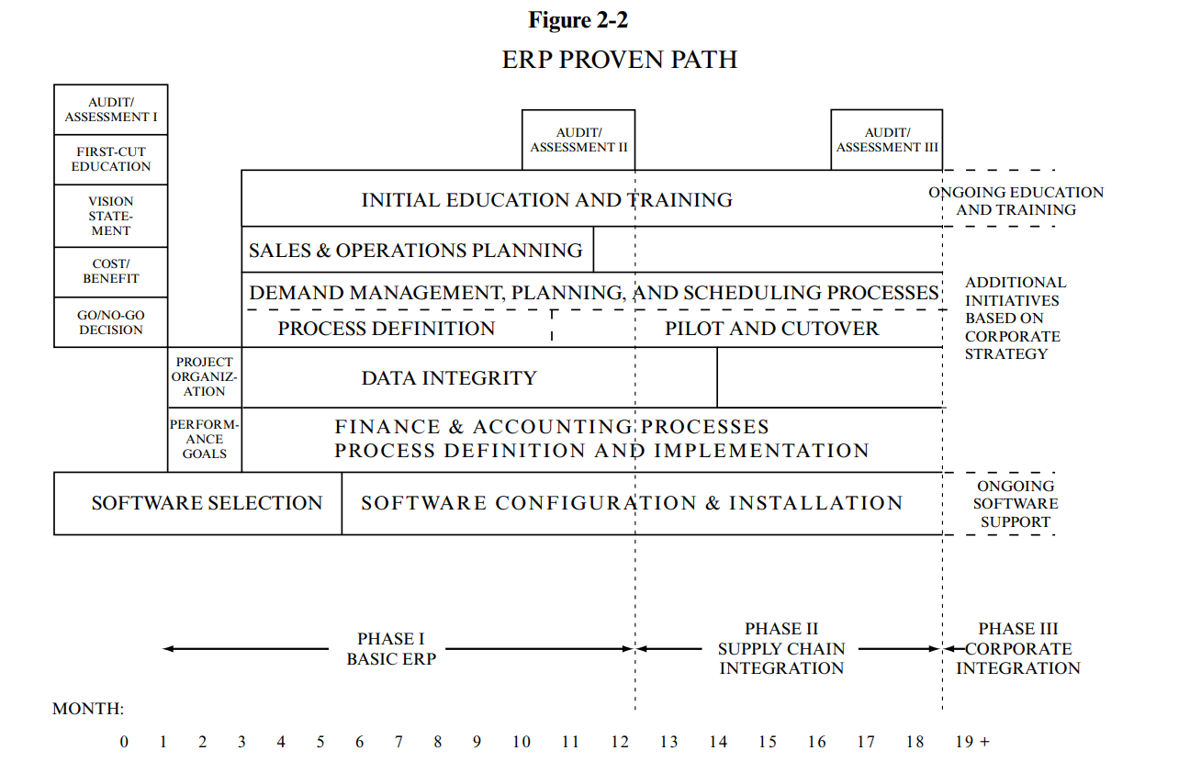

* Cost/Benefit Analysis: It is a process of creating a report or document that contains the costs of implementation and the benefits of operating ERP in the success of institutions and companies and helps in making decisions regarding follow-up or not.
* Go/No-Go Decision: It is an important matter to determine the possibilities regarding managing the business well and being a competitor to companies so that it is known whether the ERPs are suitable for the company so that it leads you to other projects. If there are benefits, you must move forward and the decision will be clear from the top of the organization.
* Vision Statement: It is a document in which the operational environment requirements that will be achieved through the implementation of ERP are written, which is: What changes will happen to the organization and the outlook for the future after implementation?
* Performance Goals: The goals expected to be implemented within the system must be determined by agreeing on performance and the things that are expected to happen within the system.
* Project Organization: It is responsible for the project, which is a team or executive steering committee consisting of department managers in all areas of the company, so that the people who will work full-time in the project are identified.
* Initial Education and Training: All employees in the company need to be educated about how to use the ERP in order to help in the success of the project, which leads to changing some of the employees’ functions and the way they work. Therefore, they need to know the changes in the way they work and provide feedback in order to make modifications to the system.
* Implementing Sales & Operations Planning: Planning for operations and sales is considered an essential part of ERP planning, and it is one of the important matters because it affects the correct functioning of the system because it is planned before implementing the system, so it is implemented early in order to obtain benefits before implementation.
* Demand Management, Planning, and Scheduling Processes: It is an important element because it balances sales, supply, and demand. For example, it is determined through two paths to forecast the best-selling products during this month by identifying customer requests, planning, and the other, and implementing these processes through an experimental and brief approach.
* Data Integrity: You need to ensure the integrity of the data to ensure the success of the ERP by ensuring that it is accurate and properly organized, such as records, invoices for materials, and other data.
* Finance and Accounting Processes—Process Definition and Implementation: You must define the financial processes of the accounting system and ensure their implementation accurately because of their importance to institutions, but it is easy because people are more mature in developments and understanding.
* Software Selection, and Software Configuration Installation: The selection of the program and additional programs for the system in developing the ERP is a major matter in building the system and may cause penalties in various departments.
* Audit/Assessment II: Evaluating the functions of each department to identify problems after implementing the system is important in correcting problems from the beginning in order to improve functions and processes and reduce errors.
* Ongoing Education: Continuing education and training for employees makes them able to benefit from all the features within the system and helps improve and develop operations.

There are many reasons why the fixed path is very effective, including compatibility with the ABCs of ERP. For example, data and computers, it reflects priorities, ensures synchronization with the ERP structure, and addresses people’s problems. The organization must follow the steps of the fixed path to avoid the occurrence of problems because it will help the company develop.

# Evaluate the impact of ERP solutions on the economy

It greatly affects the economy of companies and institutions, first in terms of productivity, as it simplifies business processes, as departments are integrated to know the stored resources, monthly sales, quantities, and profits. It automates routine tasks, which leads to increased productivity by making employees more focused on important activities and jobs while allowing... By accessing real-time data and improving decision-making processes, secondly, reducing costs of manufacturing materials, purchasing devices and servers, and reducing the need for multiple software packages, which makes the cost of infrastructure low while reducing manual work, which makes the organization not need many employees. Third, it seeks to improve the decision-making process. Through long-term forecasting and keeping pace with developments and market changes, which allows for the development of plans and strategies to assist and respond quickly to customer changes and requests. Fourth, it allows compliance with regulatory requirements by standardizing operations and adhering to international regulations. Fifth, it allows for greater development and scalability than other companies, which makes companies that use ERP in Progress and continuity in meeting the market and customer needs. Sixth, it helps reduce risks by increasing security measures to protect the organization and customers to enhance confidence and reduce threats, which increases growth and dominance of the market with the possibility of expanding the scope in various fields, which increases innovations, the possibility of competition, economic stability, increasing profits and reducing costs. Operation, which makes companies and institutions more competitive across various industries and affects them positively.

The impact of ERP is on the economy in various companies, such as government institutions and small and large companies:

1. Government Institutions: Most government institutions deal with complex and extensive procedures, and through the use of ERP it will reduce and simplify processes, ensure the accuracy and integrity of data, access to it in real time, and improve services to citizens with the possibility of making decisions that are more beneficial to the citizen, thus reducing the use of papers and transactions that need to be audited. This reduces the occurrence of errors, and this helps governments improve productivity and the economy by transferring transactions and procedures into a system to ensure that data is not lost.
2. Small and medium companies: The ERP system helps in providing services and features similar to large companies, so that it helps them compete in the market more effectively, quickly, and in the simplest ways, such as tracking orders and production, which makes them compete with large companies in services and makes them capable of developing, expanding, and growing faster in the future. Using this system there is no need for a huge infrastructure to compete by using the cloud that deals with increasing requests and integration with most third-party applications, which reduces costs and increases profits.
3. Large companies: For large companies, they have a huge infrastructure so that they can develop a specific department using ERP to perform additional functions, which leads to improving their expertise in a specific field, which enhances efficiency, productivity, and integration with various departments. ERP can be used to provide future insights due to big data and taking Decisions that affect the market, which makes the company increase sales in a service or product through promotion and attracting customers’ attention. This increases the profits of large institutions and has an impact on the market and helps more with innovation and progress in technology and simplifying operations.

# Odoo Final: -

It was created by Odoo, a business management system for offices that helps students find scientific books that help them in the fields they are interested in for different age groups. The company Papelería, aims to provide scientific books to most students at reasonable prices. The system also helps the company in identifying the best-selling products in the markets, stored resources, and quantities. And profits and employees in the company and departments. This system also helps the company grow and compete. <https://edu-papeleria2.odoo.com/>

Logo:



## Create transactions across multiple modules of your Odoo ERP system.

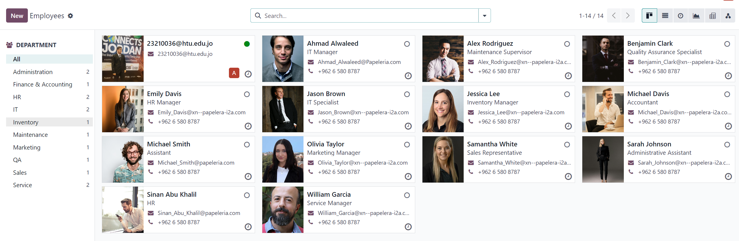

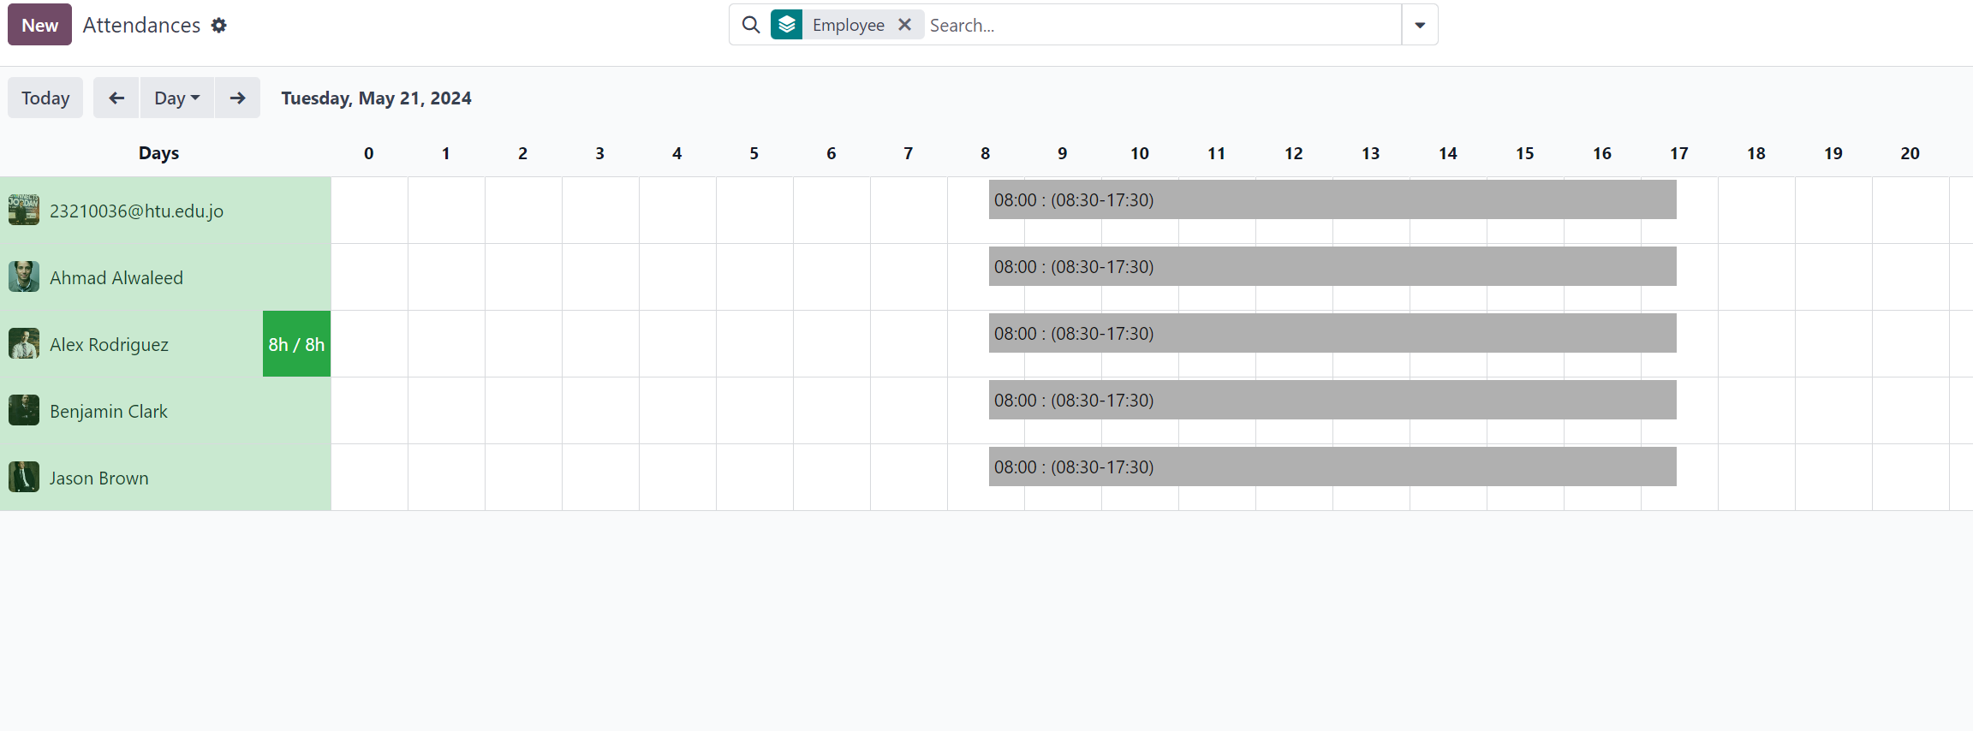

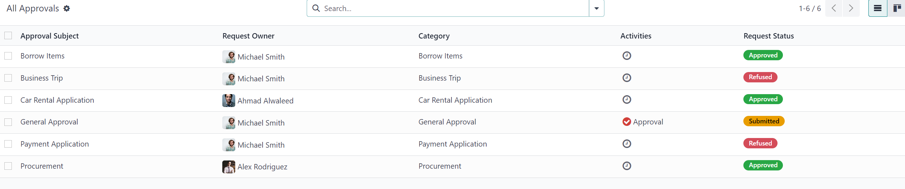

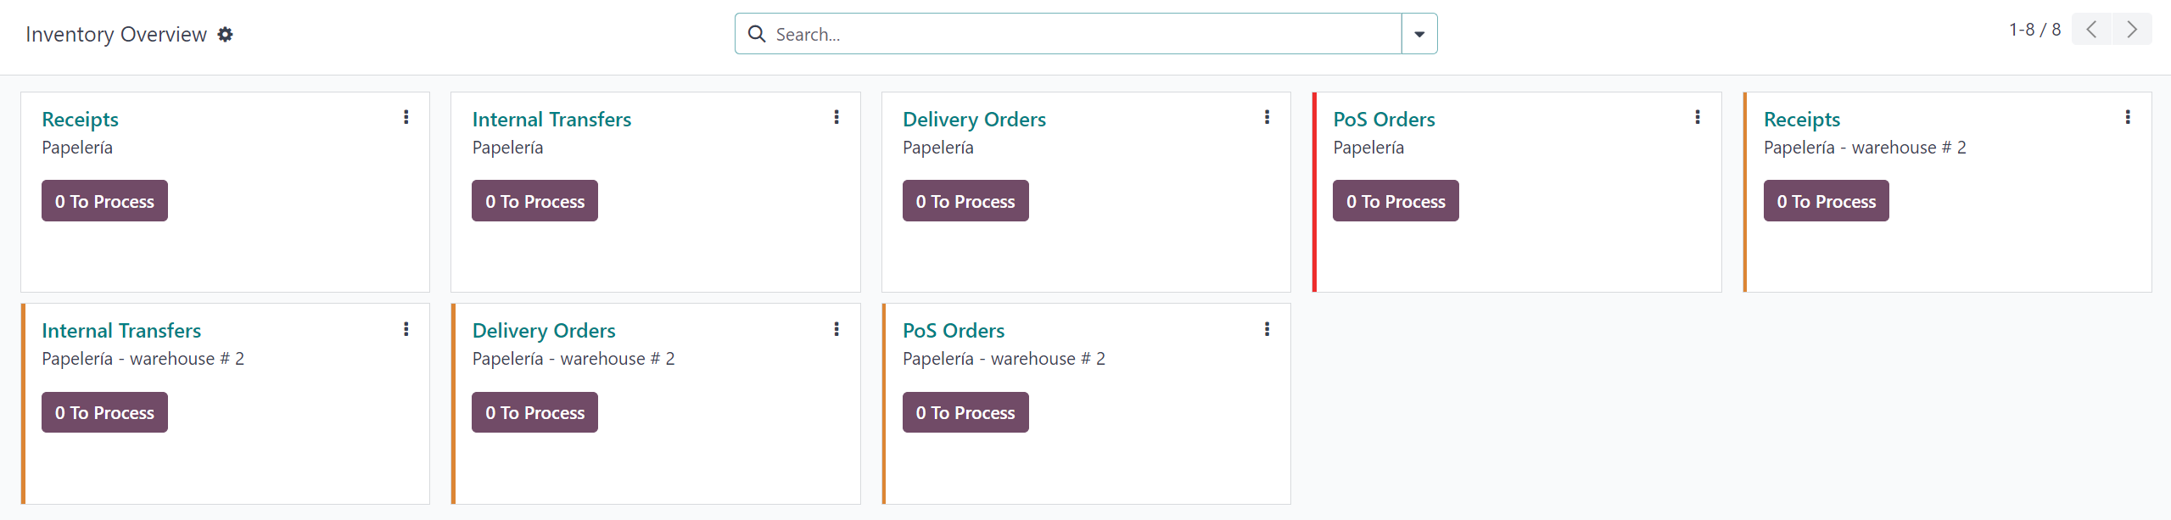



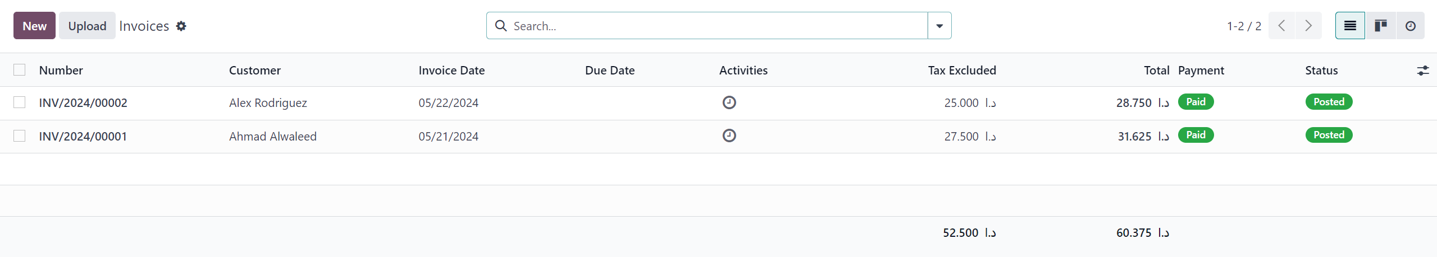

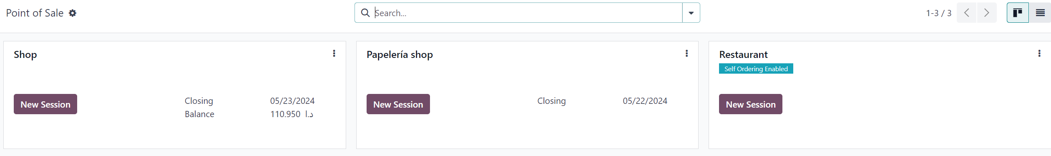

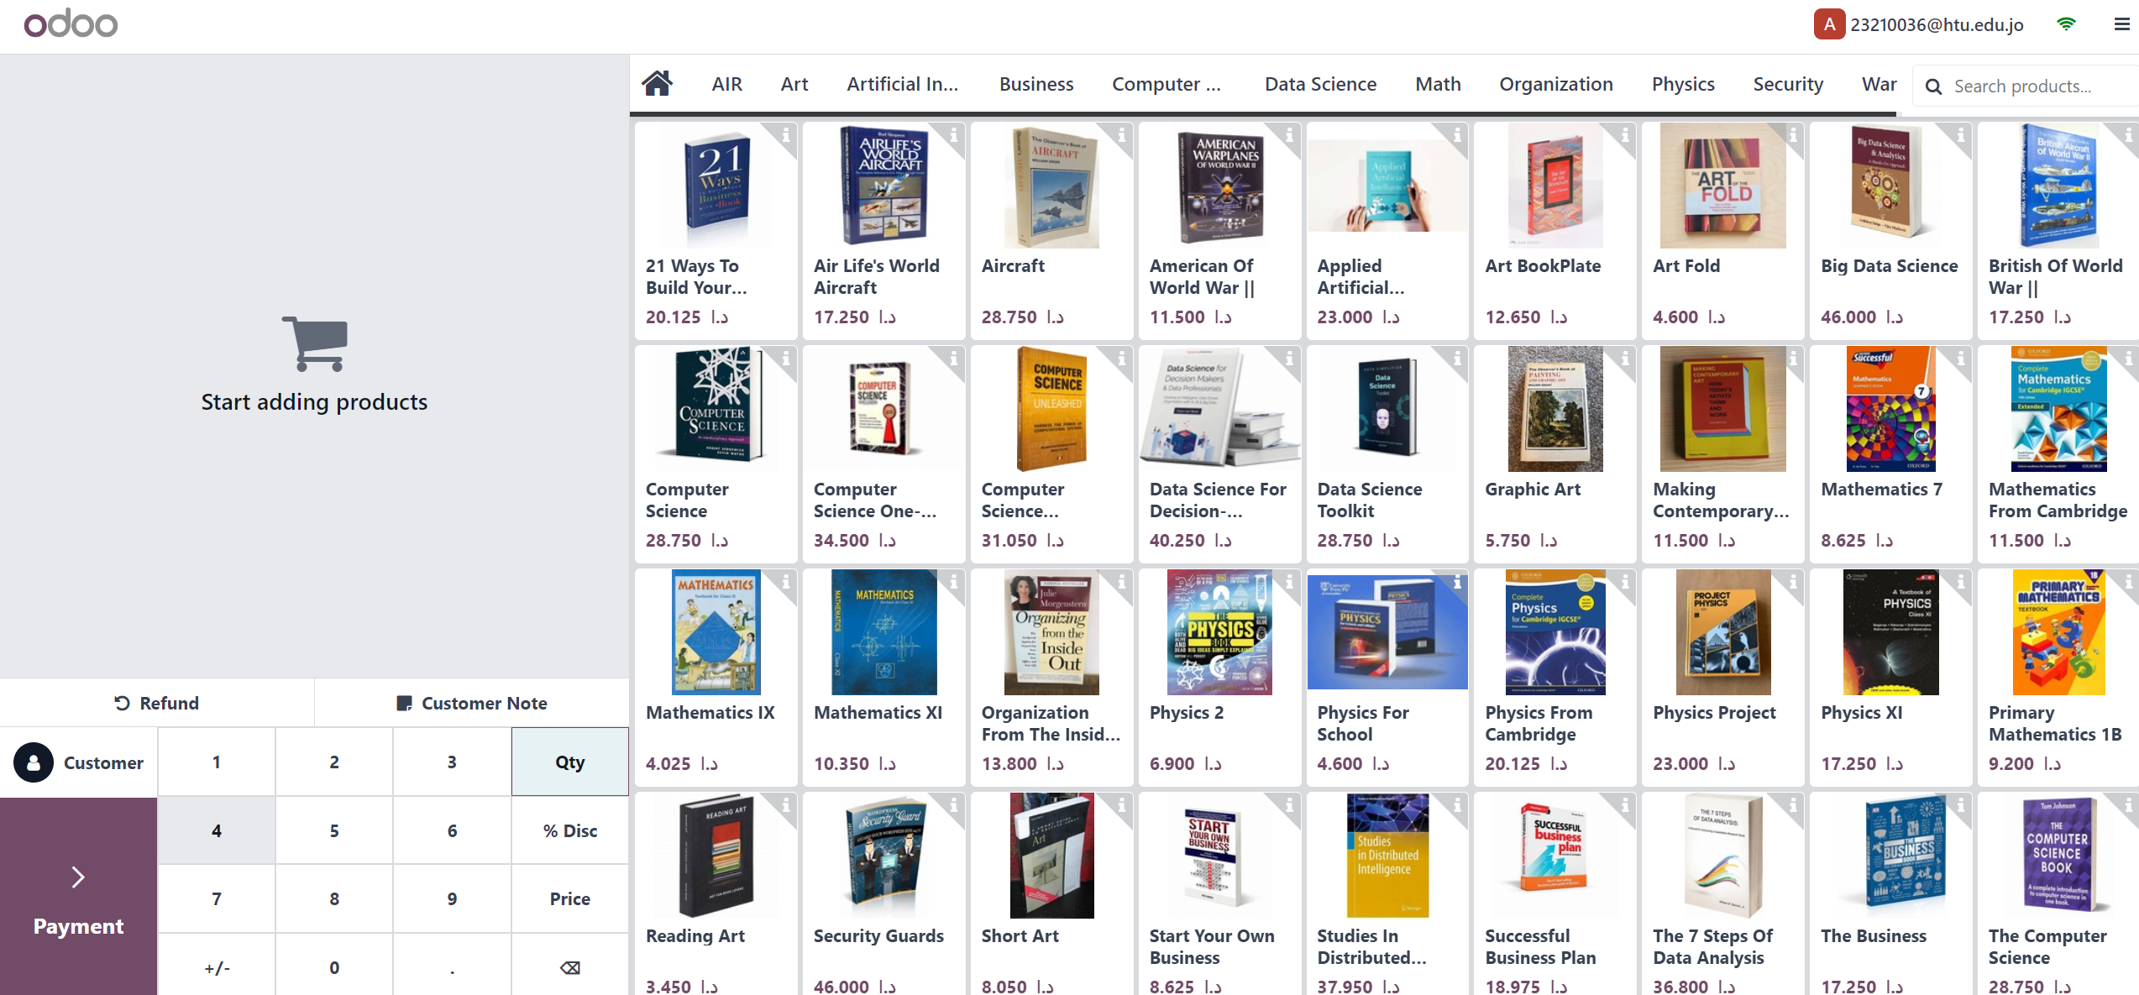

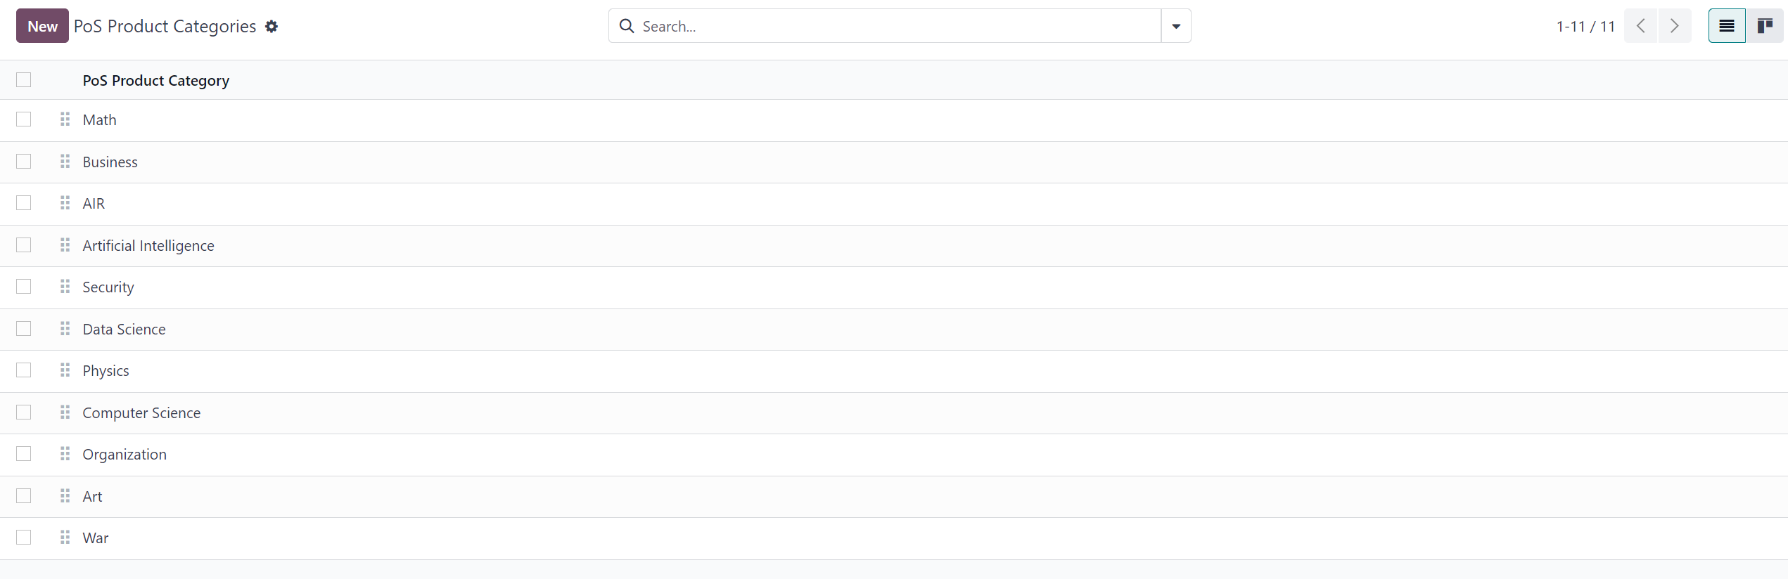

The pictures show the transactions that were created across the various units within the Odoo system. For example, all departments and employees were created and each employee was linked to his department. Also in the attendance section, work schedules were created for each employee to know the working hours of each employee in the company, and also in the approvals section where vacations are taken. Or approvals for work to another are approved by the official. Also in the inventory section, the company’s exports and imports are known, so that the quantities stored inside the warehouses are known to help in the process of buying and selling products. Also in the invoices section, all the company’s invoices that have been paid through the purchase of products are displayed. Or other things, and also in the Points of Sale section, where the library’s points of sale are created, and at each point the books available for sale are displayed, and all the books are divided into categories to make it easier for users to find books easily.

## Adjust privileges for each employee according to their responsibilities taking into consideration corresponding Access Rights.

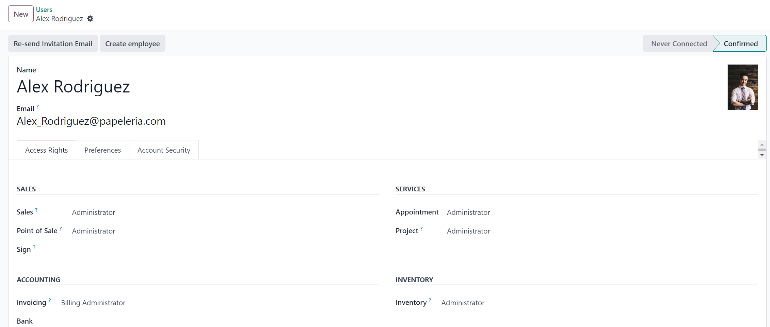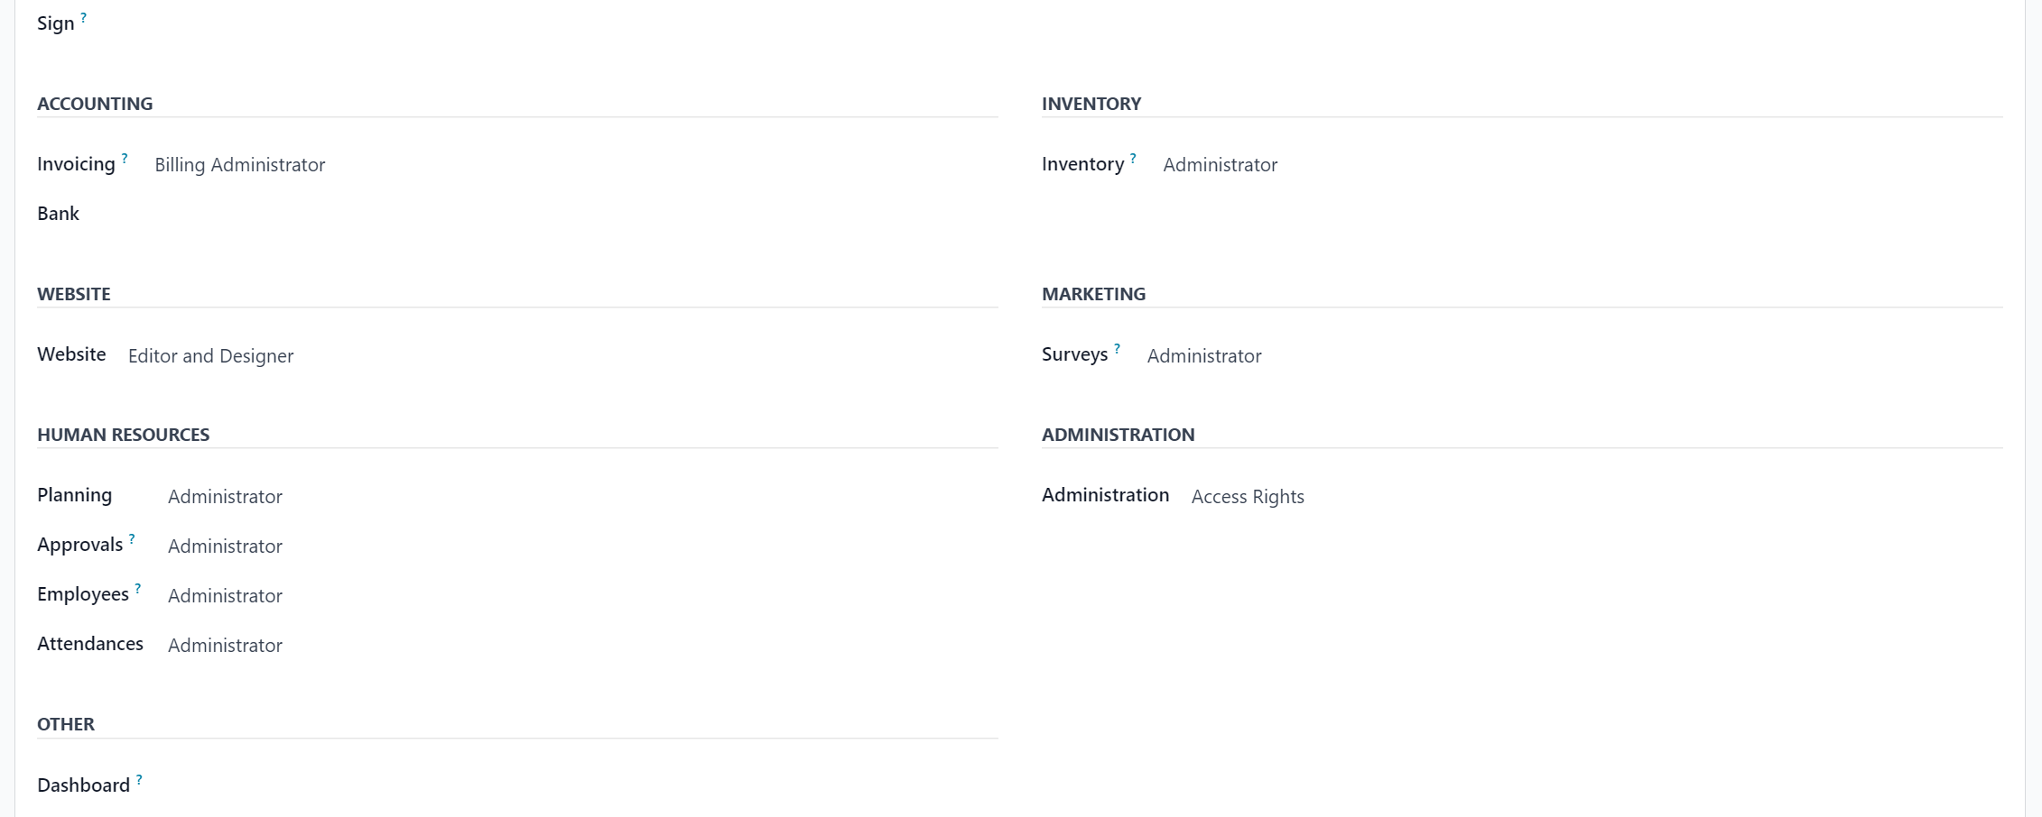

Alex Rodriguez is a maintenance supervisor who needs full system privileges because he is responsible for the problems that occur in the system, so he needs full access to most of the existing departments to avoid disrupting work.

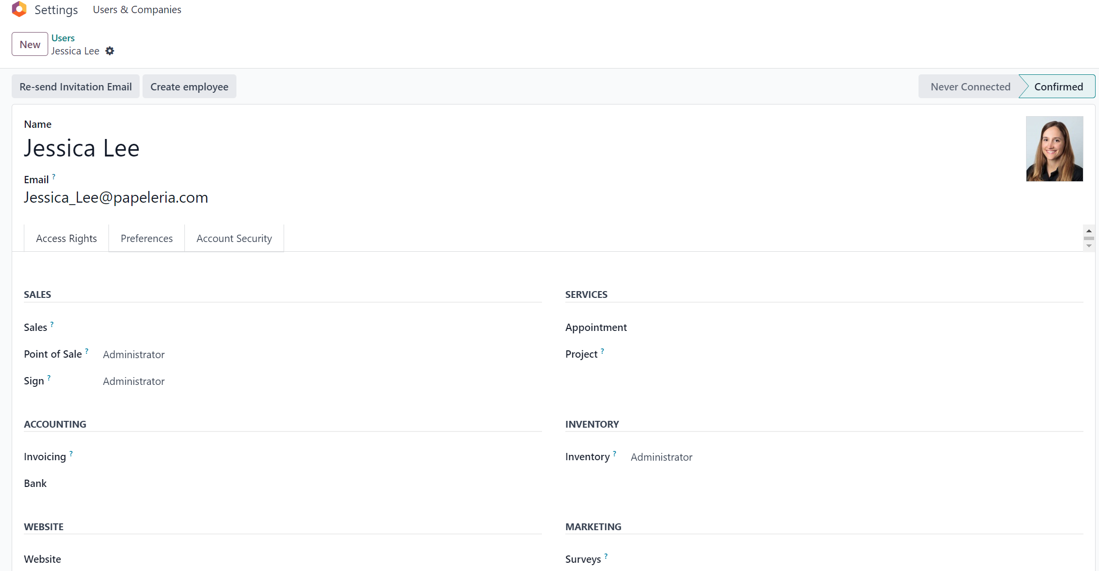

Jessica Lee is the inventory manager. She will have extended powers. For example, she cannot modify the site and cannot access financial matters. She is responsible for the products stored inside the warehouses and is responsible for the points of sale to distribute the products to various points and any matters related to inventory only.

## Sample reports from previously created transactions:

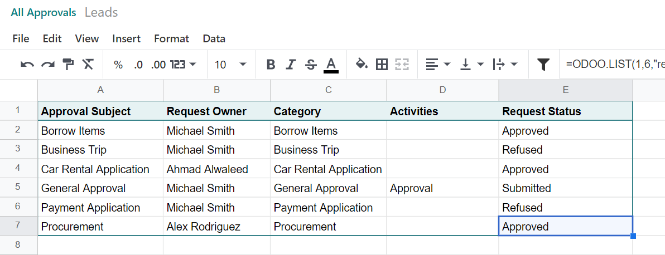

This table shows comprehensive reports of the approvals that employees need. For example, it shows the subject of the approval, the sender, and the approval status, so that officials can know all the approvals that occurred during one month, including vacations, business trips, or other matters.

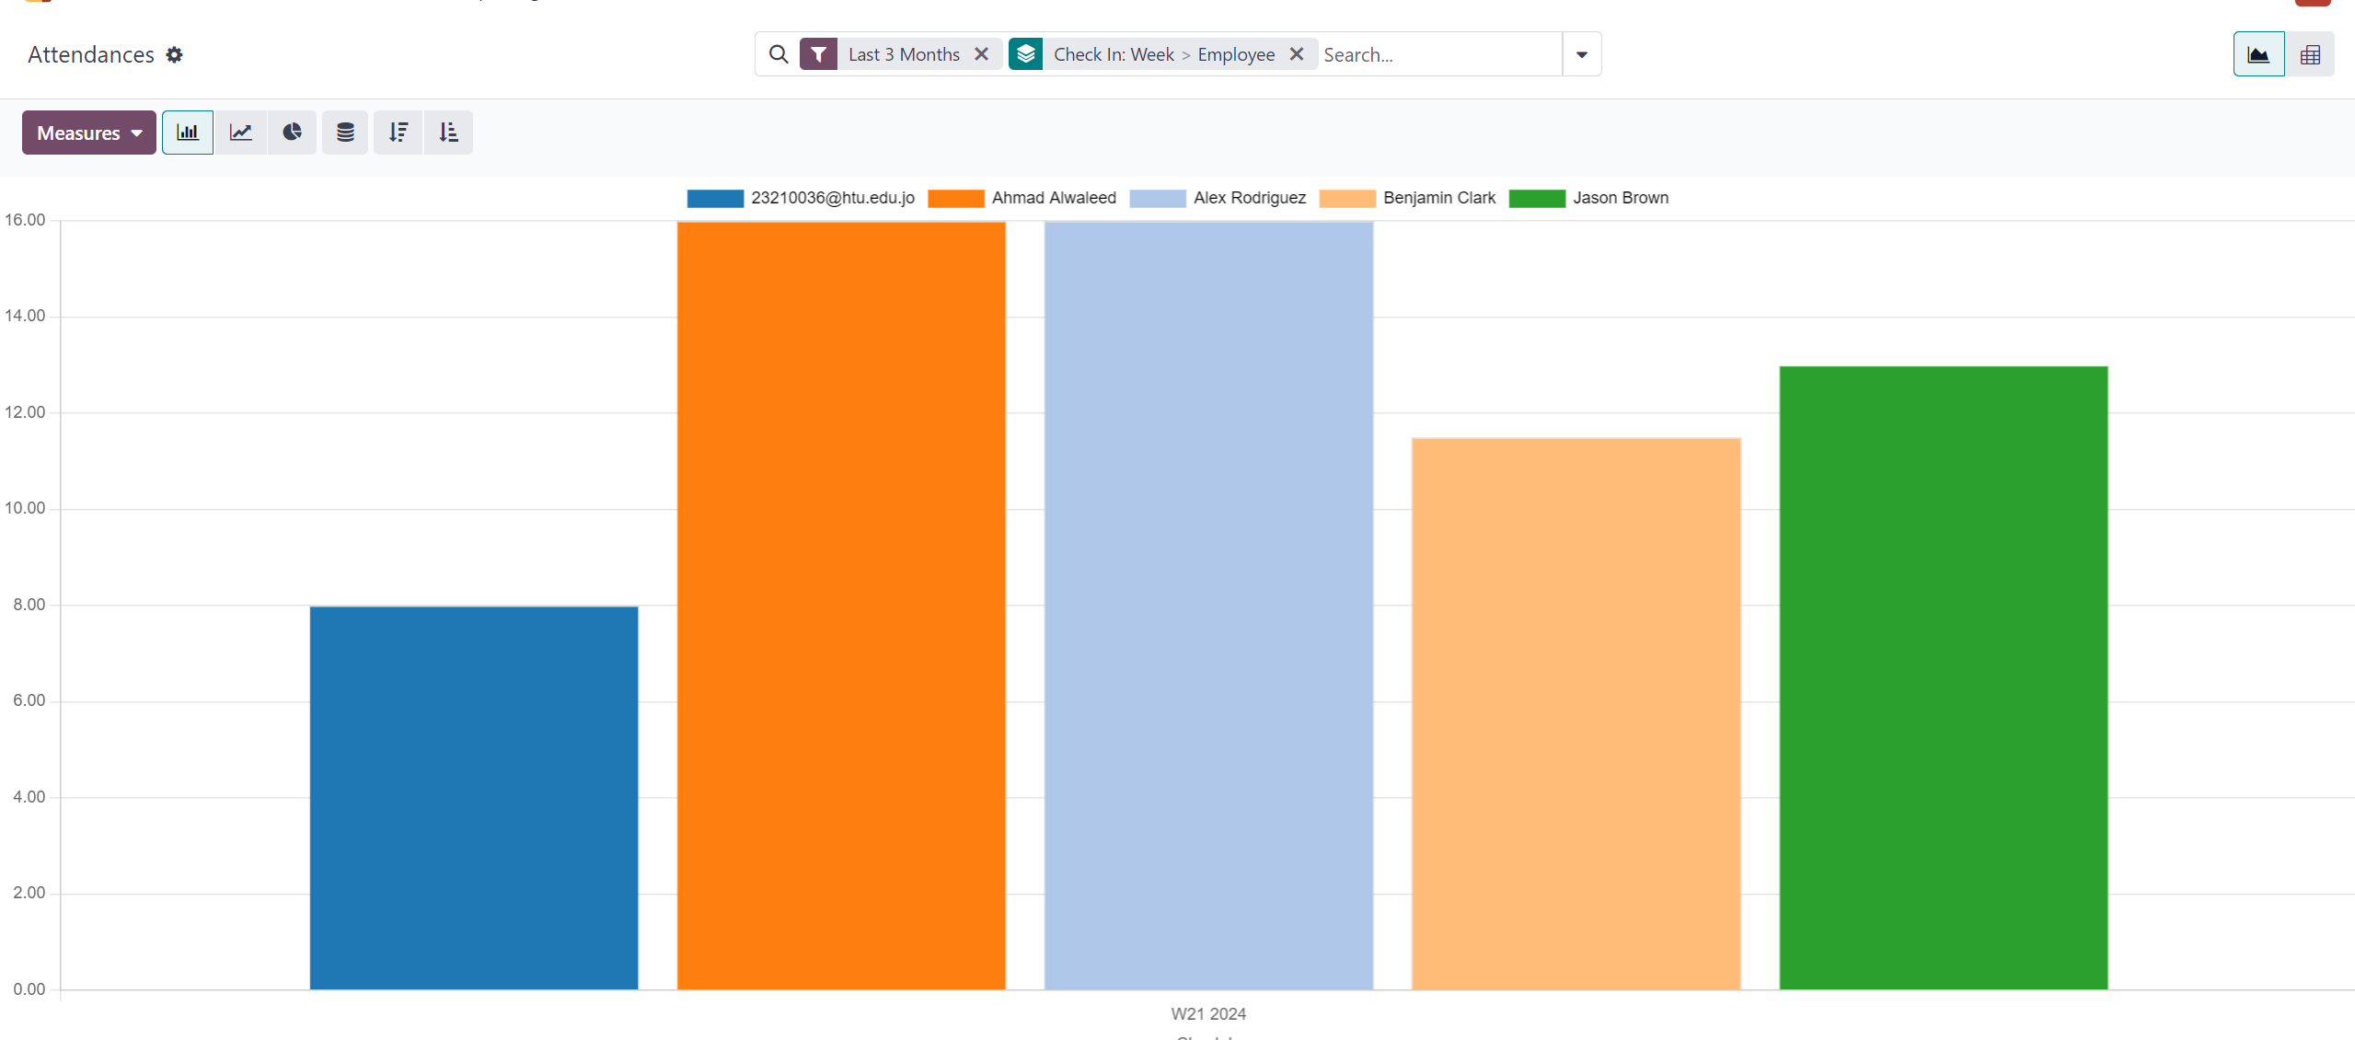

This chart shows the attendance of employees, as it shows the number of working hours of each employee in the company. It helps in knowing the hardworking employees within the company and providing rewards to motivate employees.

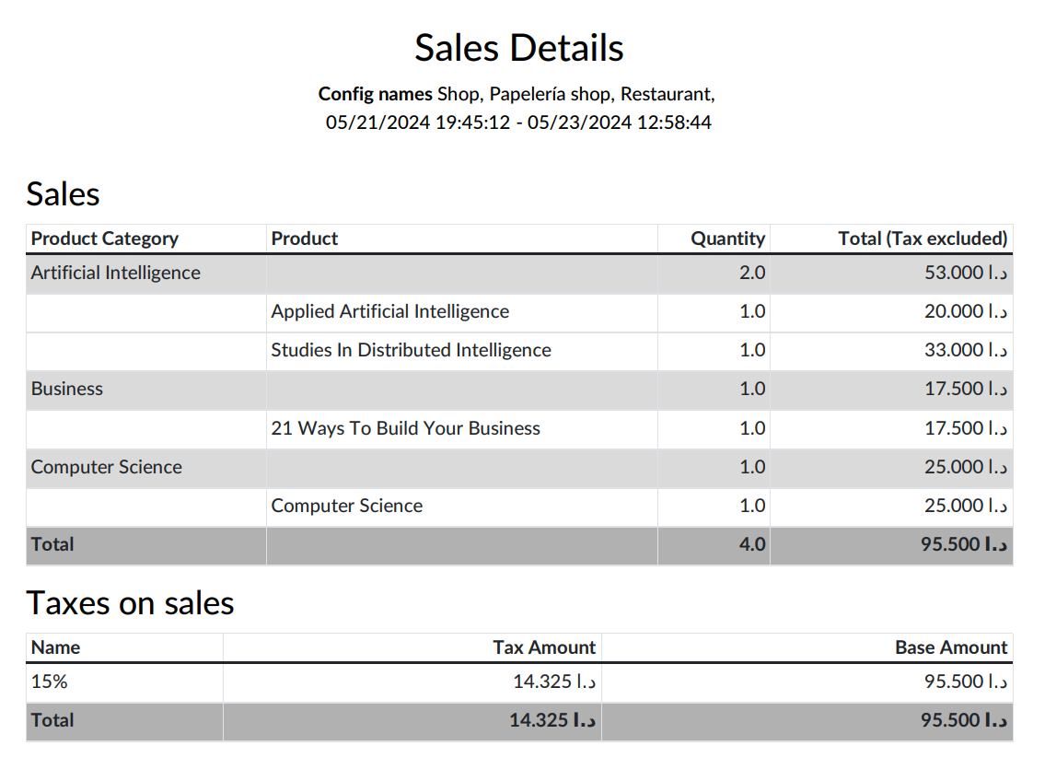

This report shows the details of sales at various points of sale during a specific period to know the sales, profits, and best-selling books at the points of sale, in addition to the tax.

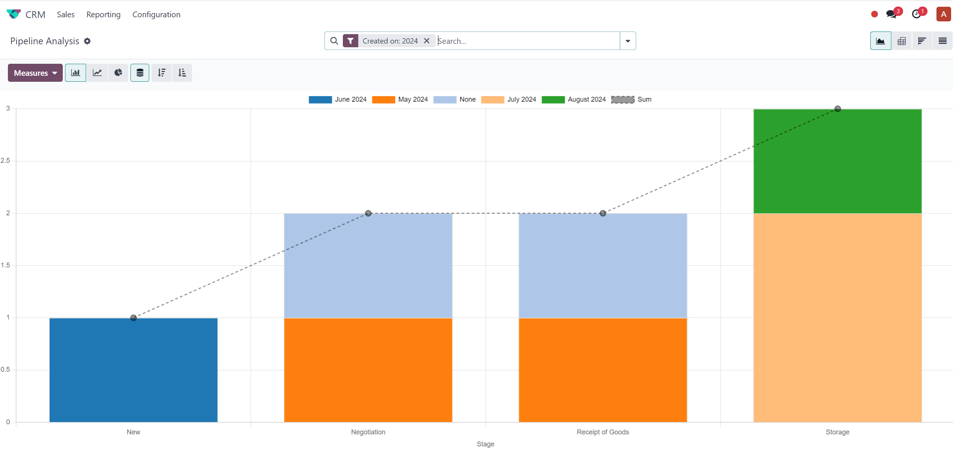

This chart shows the steps in which the process of purchasing products takes place. For example, after creating the process of purchasing products by specifying the price and the company we want to buy from and evaluating them, then in the second step the negotiation process occurs to reach an agreement. In the third step, we receive the goods from the representative and verify the quantity. In the second step, the negotiation process takes place to reach an agreement. Fourth, products are stored in warehouses.

# Resources: -

1. Making it happen - Wiley - Enterprise Resource Planning.
2. ESFM.